Customer Enquiry Inbox - Technical Report

1. System Overview
Customer Enquiry Inbox is a mini-SaaS application on cloud that is meant to run customer enquiries to companies. The platform makes use of Firebase Firestore, which synchronizes data on a real-time basis, and is deployed on GitHub Pages, which is easily deployed.

2. System Architecture Diagram
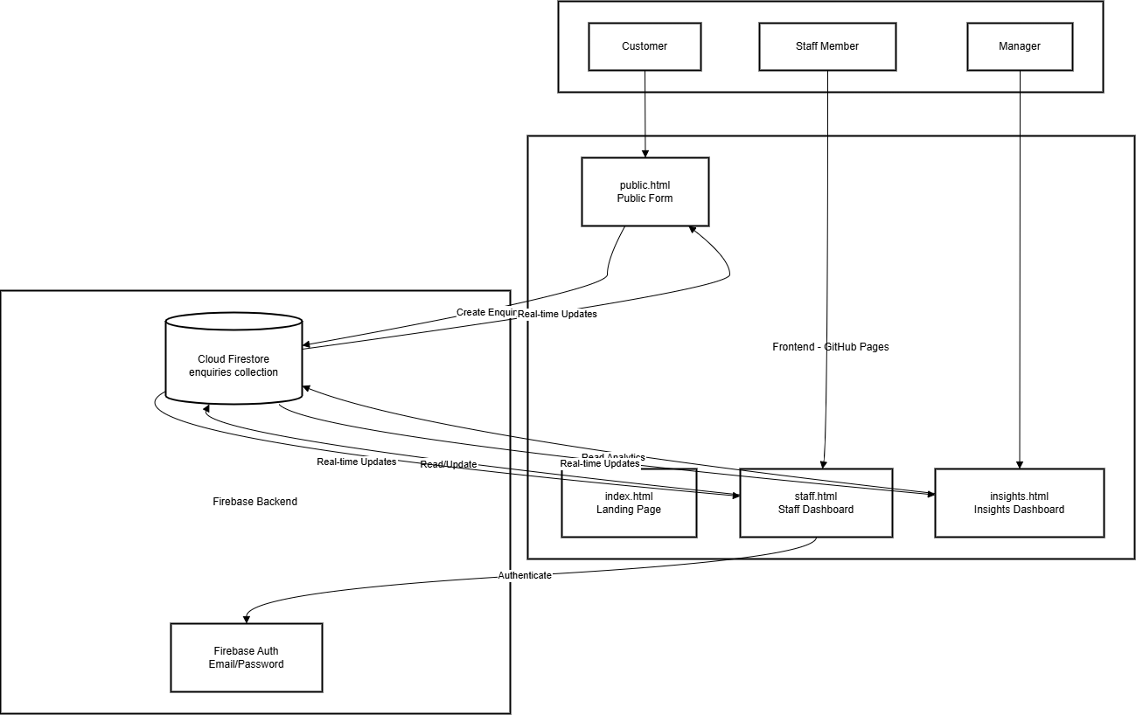
The architecture diagram shows the way the frontend modules (public.html, staff.html, insights.html, index.html) do not practise on GitHub Pages are linked to the Firebase backend services. Roles determine the type of interaction with the various modules by the users (Customer, Staff Member, Manager). Every module has the same Cloud fire store database where real time data is synchronised.

3. Data Flow Diagram
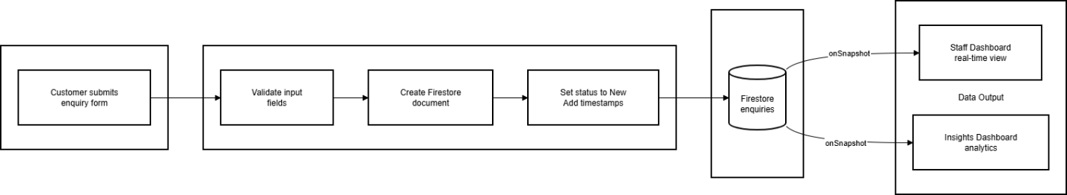
This diagram shows the flow of data through the system:
- Customer submits an enquiry form
- Input fields are validated
- A Firestore document is created
- Status is set to "New" with timestamps
- Data is stored in Firestore enquiries collection
- Staff Dashboard and Insights Dashboard receive real-time updates via onSnapshot listeners

4. User Flow Diagram
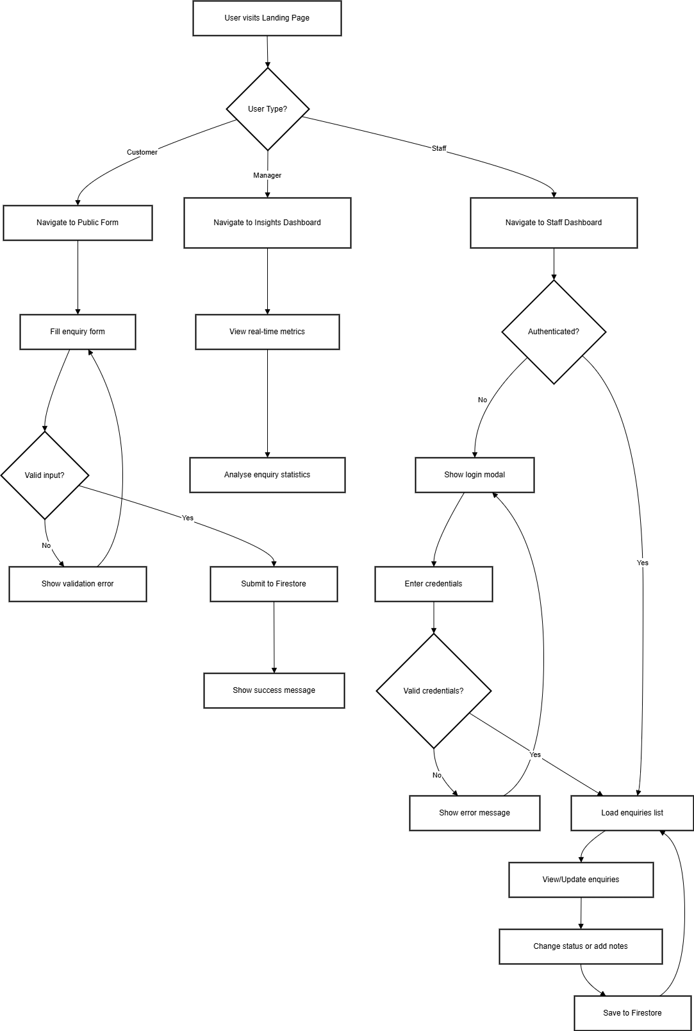
The user flow diagram maps out the complete journey for all user types:
- Customers: Navigate to public form, fill details, submit enquiry
- Staff: Navigate to staff dashboard, authenticate, view/update enquiries
- Managers: Navigate to insights dashboard, view real-time metrics

5. Firestore Data Model
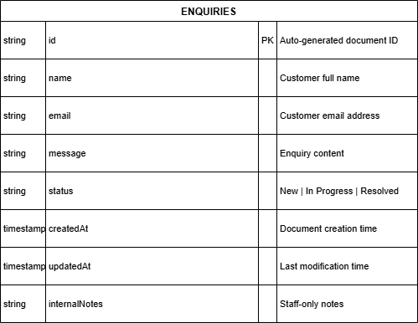
The ENQUIRIES collection stores documents with the following fields:
Type | Field | Description
string | id (PK) | Auto-generated document ID
string | name | Customer full name
string | email | Customer email address
string | message | Enquiry content
string | status | New / In Progress / Resolved
timestamp | createdAt | Document creation time
timestamp | updatedAt | Last modification time
string | internalNotes | Staff-only notes

6. Authentication Flow
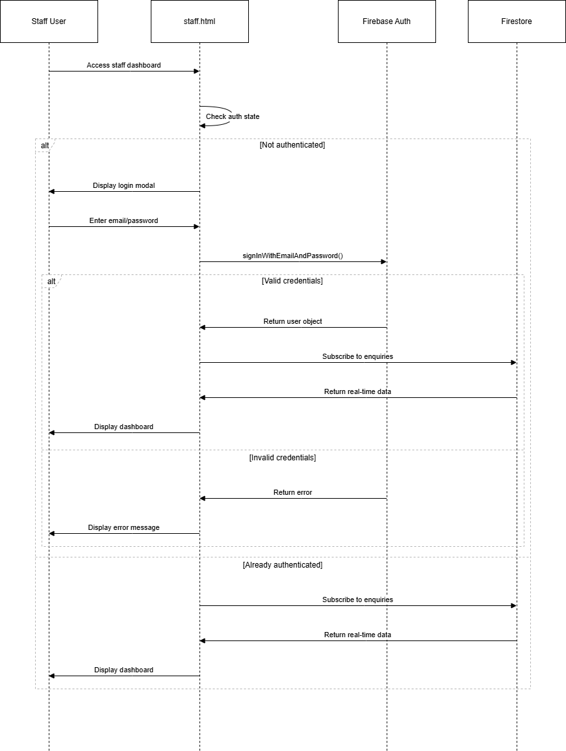
The sequence diagram illustrates the authentication process:
- Staff user accesses the staff dashboard
- System checks authentication state
- If not authenticated, login modal is displayed
- User enters email/password credentials
- Firebase Auth validates credentials
- On success: Subscribe to Firestore and display dashboard
- On failure: Display error message
- If already authenticated: Directly subscribe to enquiries

7. Real-Time Update Mechanism
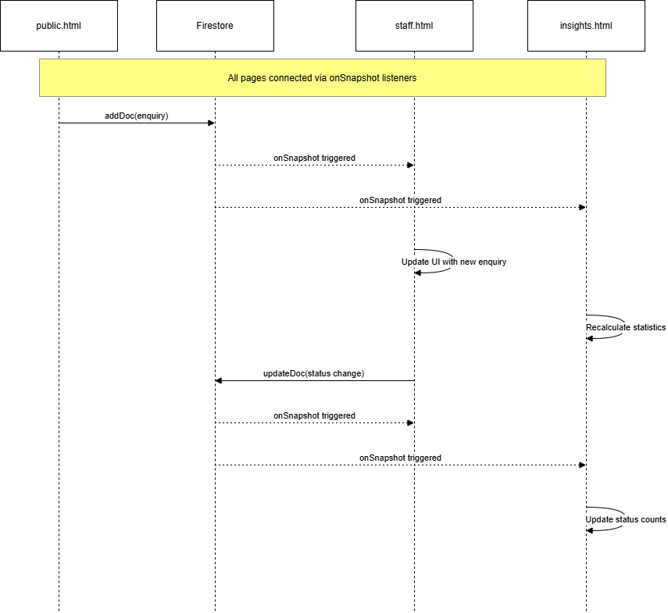
This sequence diagram demonstrates real-time synchronization:
- All pages are connected via Firestore onSnapshot listeners
- When public.html adds a document, both staff.html and insights.html receive updates
- When staff.html updates a document status, insights.html recalculates statistics
- No page refresh is required for updates to appear

8. Component Architecture
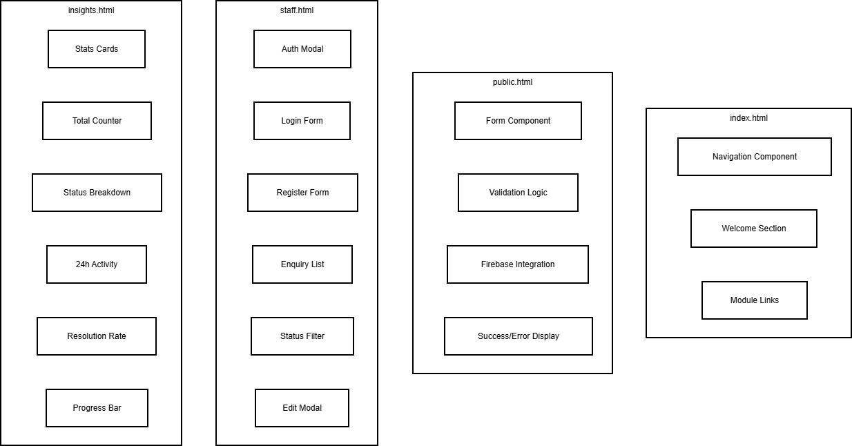
Each HTML module contains specific components:
index.html:
- Navigation Component
- Welcome Section
- Module Links
public.html:
- Form Component
- Validation Logic
- Firebase Integration
- Success/Error Display
staff.html:
- Auth Modal
- Login Form
- Register Form
- Enquiry List
- Status Filter
- Edit Modal
insights.html:
- Stats Cards
- Total Counter
- Status Breakdown
- 24h Activity
- Resolution Rate
- Progress Bar

9. Technology Distribution
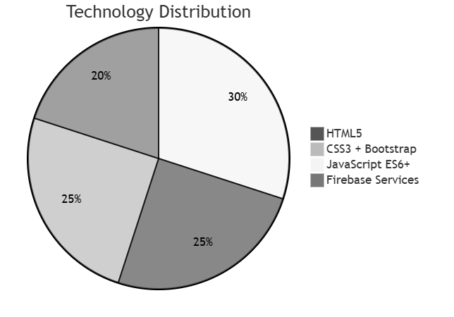
The technology stack distribution:
- JavaScript ES6+: 30% - Core application logic
- HTML5: 25% - Page structure and content
- CSS3 + Bootstrap: 25% - Styling and responsive design
- Firebase Services: 20% - Backend infrastructure

10. Security Model
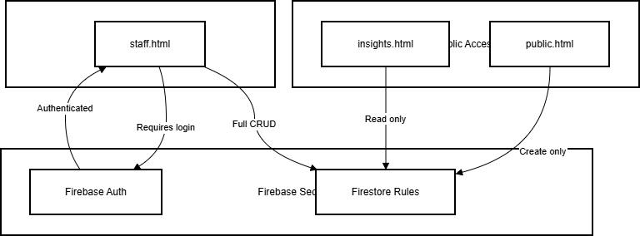
The security model defines access levels:
- Public Access: public.html (Create only), insights.html (Read only)
- Protected Access: staff.html (Requires Firebase Auth login, Full CRUD operations)
- Firebase Security: Firestore Rules control data access based on authentication state

11. Firebase Console Screenshots

11.1 Firebase Project Creation
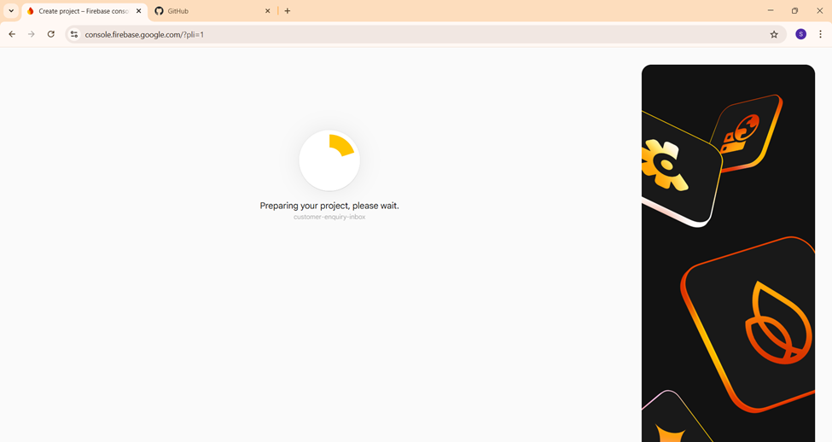
The screenshot shows the Firebase Console during project initialization. The project "customer-enquiry-inbox" is being prepared for use.

11.2 Firestore Database - Collection Setup
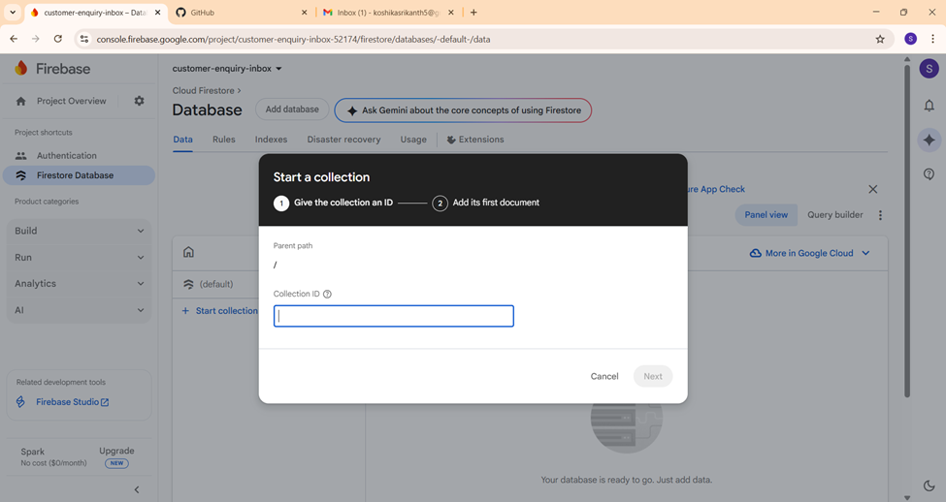
This screenshot demonstrates the Firestore database interface where the "enquiries" collection is being created. The collection stores all customer enquiry documents.

11.3 Firestore Security Rules
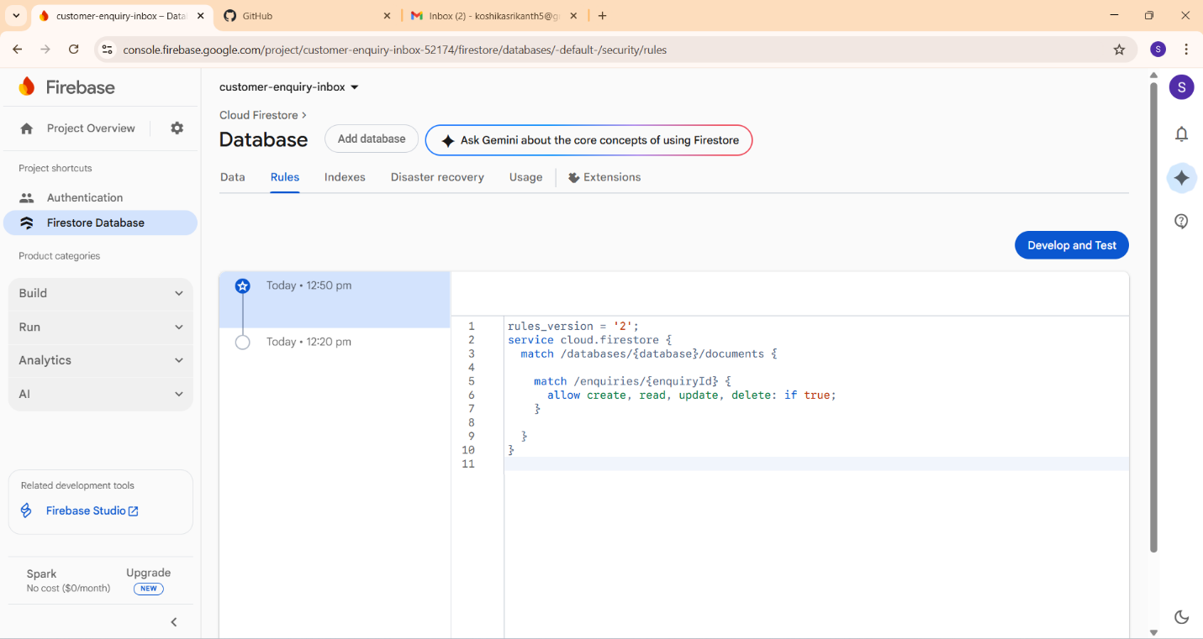
The security rules configuration in Firebase Console showing the rules applied to the enquiries collection:
- Rules version: 2
- Service: cloud.firestore
- Match path: /enquiries/{enquiryId}
- Permissions: allow create, read, update, delete: if true

11.4 Firebase Project Settings
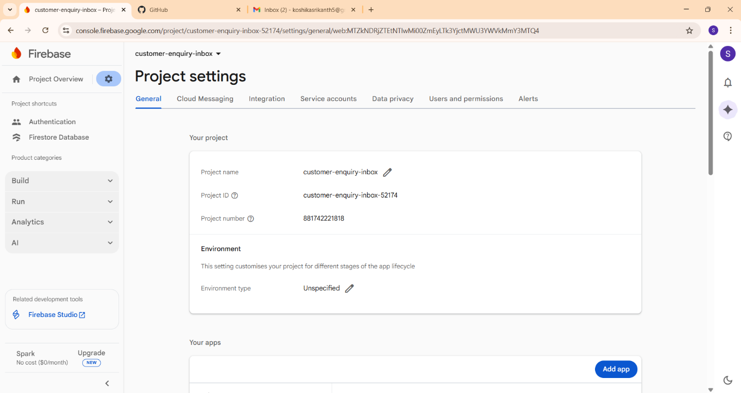
The project settings page showing:
- Project name: customer-enquiry-inbox
- Project ID: customer-enquiry-inbox-52174
- Project number: 881742221818
- Environment type: Unspecified

12. Module Interaction Summary
Module | Access Level | Operations | Real-time
public.html | Public | Create | No
staff.html | Authenticated | Read, Update | Yes
insights.html | Public | Read | Yes

13. Conclusion
The Customer Enquiry Inbox system demonstrates effective use of cloud-based technologies:
- Serverless Architecture: No backend server required, reducing operational costs
- Real-time Updates: Firebase onSnapshot provides instant data synchronization
- Modular Design: Each page is self-contained yet integrated through shared database
- Scalable Solution: Firebase handles scaling automatically
- Easy Deployment: GitHub Pages provides free, reliable hosting
This architecture is suitable for small to medium businesses looking for a cost-effective customer enquiry management solution.

